

**PROJECT FOR SQL MODULE**

**HEALTH CARE DATABASE MANAGEMENT**

**Institute name** = It vedant education Pvt. Ltd.

**Name** = vikrant subhash matele

**Email address** = [matelevikrant@gmail.com](mailto:matelevikrant@gmail.com)

**Date of submission** = 13-08-2024

**Project aims:**

**Improving Patient Care**:

* Enhancing the quality and accessibility of patient care services.

**Health Promotion and Disease Prevention**:

* Educating the public about healthy lifestyle choices.

**Enhancing Healthcare Systems**:

* Improving healthcare infrastructure and facilities.

**Research and Innovation**:

* Conducting clinical trials and medical research.

**Workforce Development**:

* Training and educating healthcare professionals.

**Access and Equity**:

* Reducing health disparities among different populations.

**Project objective:**

The objective of the A Healthcare Management Database project is to design and implement a comprehensive database system that efficiently manages and stores information related to the Health Care operations, including Patients and Doctor Details, Exhibitions, Medications, Billing, and Appionments activities. The system aims to streamline gallery operations, improve data accuracy and accessibility, enhance patients engagement, and support business growth through data-driven insights and reporting. By achieving this objective, the project will provide a robust and scalable solution for the health care to manage its diverse activities, make informed decisions, and maintain its competitive edge in the hospital industry.

**ER diagram of the project:**

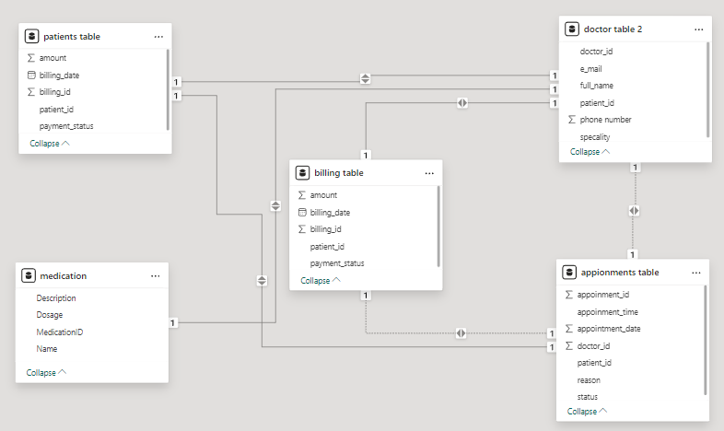

**ER diagram description:**

**Entities:**

* Patient (Patient_ID,Full Name,date_of_Birth, Gender, Contact info)
* Doctors (Doctor_ID,patient_ID Fullname, Speaiality, Email, Contact info)
* Appionments (Appionments_ID, Title, Start_Date, End_Date)
* Medications (Medication_ID, Name, Description, Dosage)
* Billing (Billing_ID, Patient_ID, Amount, Billing_Date, Payment_status)

**Relationships:**

* An doctor can handle many patients (one-to-many).
* An patients is attend by one doctor (many-to-one).
* An patients can give one appionments (one-to-one).
* An patients can be create only one bill (one-to-one).
* A patients can give many maedicine (one-to-many).

**Table description:**

1. **Patients**

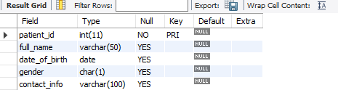

1. **Doctors**

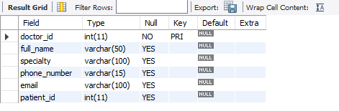

1. **Medications**

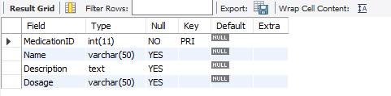

1. **Appionments**

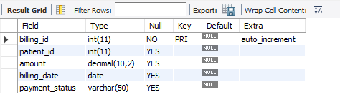

1. **Billing**

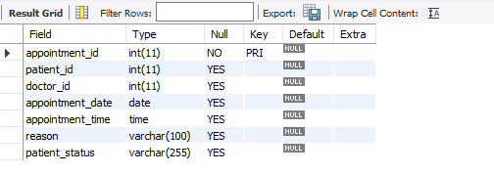

**Commands:**

**Select * from patients**

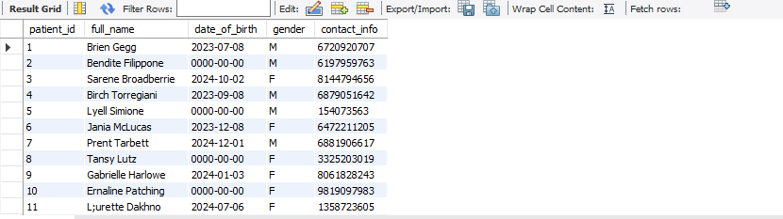

**Select *from doctors**



**Select * from medication**

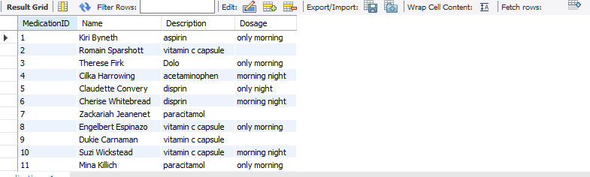

**Select * from billing**

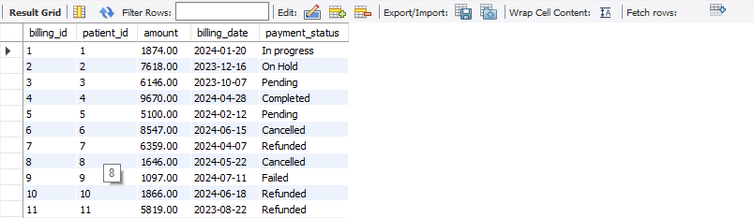

**Select * from appionments**

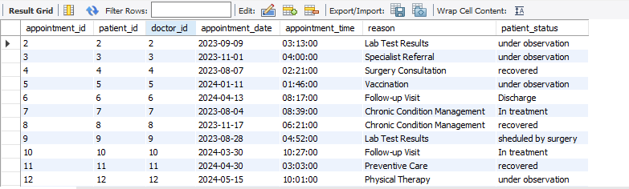

**JOIN QUERIES :**

1. show the payment status was completed display the names by ascending.

SELECT p.patient_id, p.full_name, b.payment_status

FROM patients p

JOIN billing b ON p.patient_id = b.patient_id

WHERE b.payment_status = 'completed'

ORDER BY p.full_name ASC;

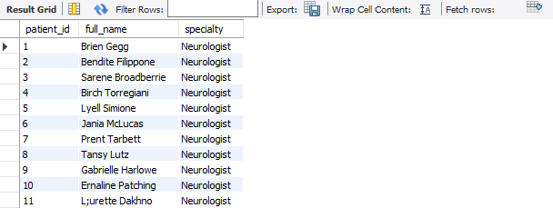

1. show the patient id full name speciality specialize doctor neurologist**.**

SELECT p.patient_id, p.full_name, d.specialty

FROM patients p

LEFT JOIN doctors d ON d.doctor_id = d.doctor_id

WHERE d.specialty = 'Neurologist'

ORDERBYd.specialty;

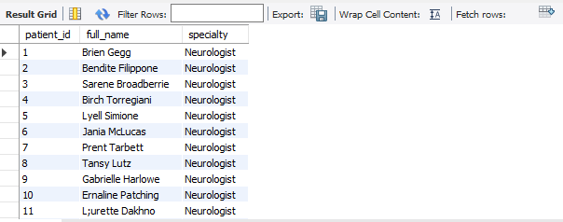

1. shows the patients id fullname patients status is under observation

select p.patient_id,p.full_name,a.patient_status

from patients p

inner join appointments a on p.patient_id = p.patient_id

where patient_status = 'under observation';

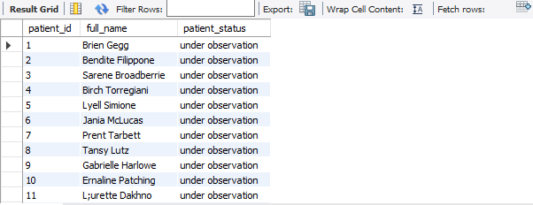

1. shows the patients id fullname patients reason is comming from vaccination

SELECT p.patient_id, p.full_name, a.reason

FROM patients p

RIGHT JOIN appointments a ON p.patient_id = a.patient_id

WHEREs.reason='vaccination';

;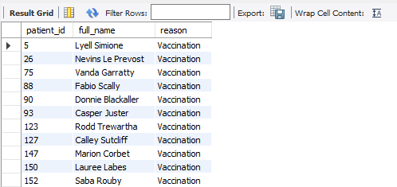

1. show the patient id fullname whose billing amount is greater than five thousands

SELECT p.patient_id, p.full_name, b.amount

FROM patients p

CROSS JOIN billing b ON p.patient_id = p.patient_id

WHERE b.amount >= '5000';

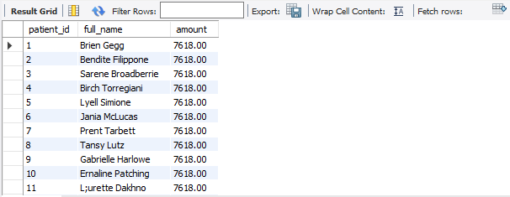

**SUBQUERIE QUERIES:**

**1)** shows the patient name and patient id who was the payment status is completed from billing.

SELECT full_name, patient_id

FROM patients

WHERE patient_id

IN (SELECT patient_id

FROM billing

WHERE payment_status = 'Completed'

);

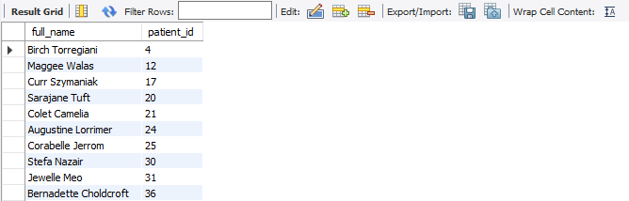

**2**) shown the patient id and full name whose billing amount is greater than one thousands

SELECT patient_id, full_name

FROM patients

WHERE patient_id IN (

SELECT patient_id

FROM billing

GROUP BY patient_id

HAVING SUM(amount) > 1000

);



**3)** find out the patient name whose payment status was cancelled

select patient_id,full_name

from patients

where patient_id in(

select patient_id

from billing

where payment_status = 'cancelled'

group by patient_id

);

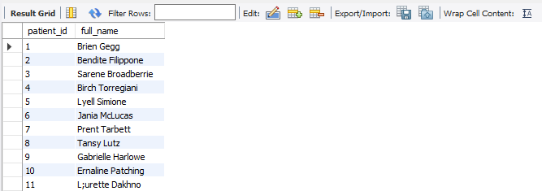

**4)** find out the patient id and full name whose patient status was under observation

select patient_id, full_name

from patients

where patient_id in (

select patient_id

from appointments

where patient_status = 'under observation'

);

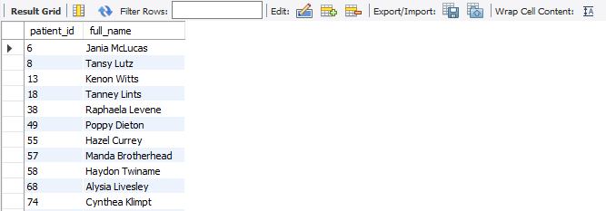

**5)** show the 2nd highest whose patient paid the more bill amount

SELECT p.patient_id, p.full_name, SUM(b.amount) AS total_paid

FROM Patients p

JOIN Billing b ON p.patient_id = b.patient_id

GROUP BY p.patient_id, p.full_name

ORDER BY total_paid DESC

LIMIT 2;

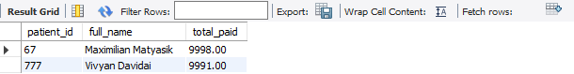

**BASIC QUESTIONS:**

1 find the patients name there description whose dosage only night**.**

select MedicationID,Name,Description from medications

where dosage = "only night";

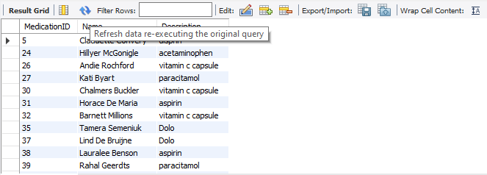

2 count of the name who gives the the dolo medicine.

select count(name) from medications

where Description = "Dolo";



**3)** count of the gender from patients

select gender, count(*) from patients

group by gender;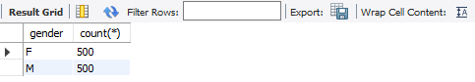

**4)** show the patients id and their name who born only in 2024**.**

select patient_id,date_of_birth from patients

where year(date_of_birth) > 2023;

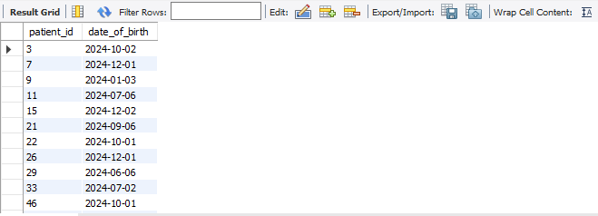

**5**) find out the patients first name from fullname.

select substring_index(full_name,' ', as first_name from patients;

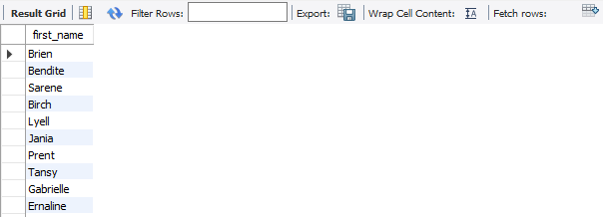

**6)** show all the doctors email id in upper case.

select upper(email) from doctors;



**7)** show the count of names of doctors grouping by their speciality.

select count(full_name), specialty from doctors

group by specialty;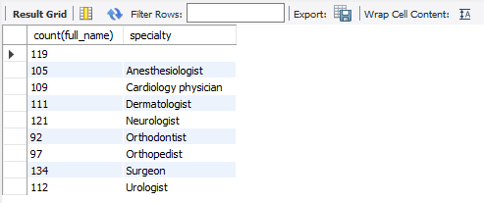

**8)** change the doctors phone number whose id is 3.

update doctors

set phone_number = 9730472167

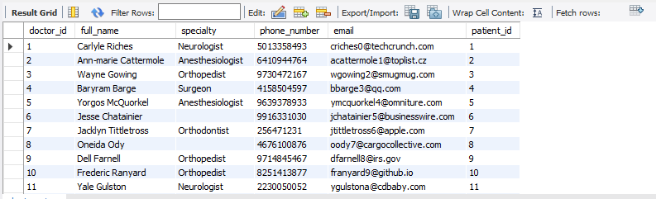where doctor_id=3;

**9** show the patients status who is under observation

SELECT * FROM appointments

WHERE status = 'under observation';

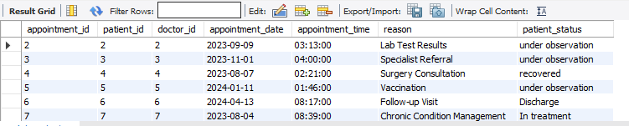

**10** show the appointments how many appointments in that date.

SELECT * FROM appointments

WHERE appointment_date = '2024-06-11';

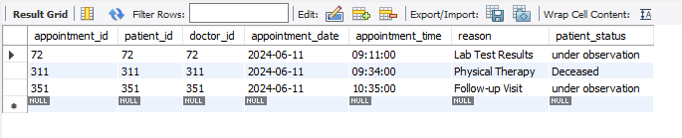

**11)** delete the appointment whose appointment_id is 1

DELETE FROM appointments

WHERE appointment_id = 1;

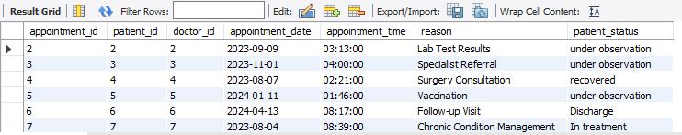

**12)** change the column name column status to patient_status.

alter table appointments

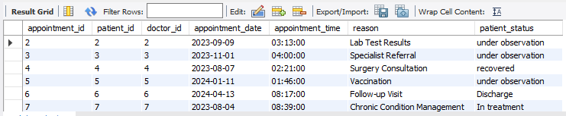change column status patient_status varchar(255);

**13)** sum of the amount is payment_status was completed from billing

SELECT payment_status, SUM(amount) AS total_amount

FROM billing

WHERE payment_status = 'Completed'

GROUP BY payment_status;



**14)** what is the id of the patients whose bill in was above thousands rupees

SELECT * FROM billing

WHERE amount > 1000;

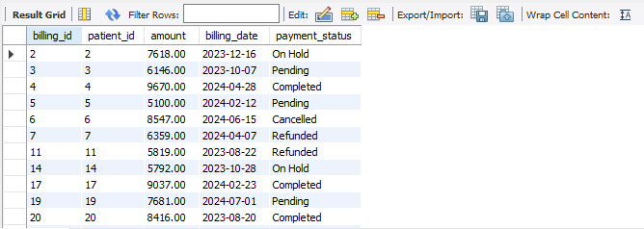

**15** show the patient whose appionment date is 2023-11-01.

SELECT * FROM Appointments

WHERE appointment_date = '2023-11-01';

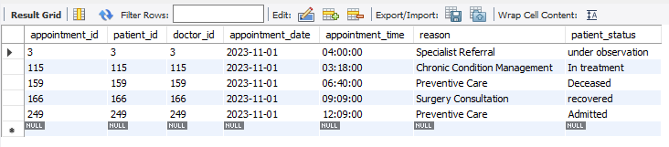

**CONCLUSION:**

The process of designing an entity-relationship diagram for a hospital management system is one that call for a thorough analysis of requirements, identification of entities, definition of attributes, and defining relationships. The foundation of an operational and efficient system lies in the carefully designed ER Diagram as it accounts for both current and future system requirements to cater to the wide range of functional needs of healthcare management**.**